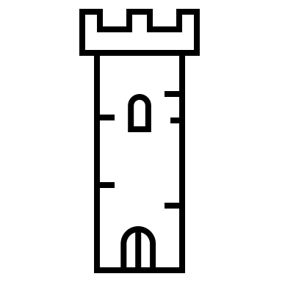
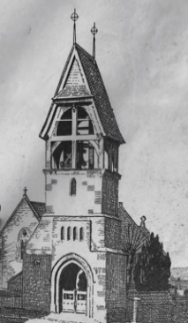
Fly the Flag
All Saints’ Church, Great Bourton
Light the Belfry

SPONSORSHIP APPLICATION FORM

I wish to sponsor the flag and/or lighting as follows:

Dates …………………...……………………………………….........…………….

Occasion .……………………………………………………………….……………….

Name …………………………………………...........………….. (see note 2 below)

Address …………………………………...…………………………………………….

Post Code ………….………………. Tel no: ………………………………...

I agree the sponsorship donation (please tick your preferred option)

Flag or Light Flag and Light
£5 per day/night £8 per day/night
£10 for 3 days/nights £16 for 3 days/nights
£20 for a week £25 for a week

Payment may be made by (please tick your preferred option)
- www.justgiving.com/fundraising/flytheflaglightthebelfry
- *Bank transfer to HSBC sort code: 40-09-02 account no: 71375423 (quoting as
reference your ‘surname’ and ‘Bell Tower’)
- *Cheque payable to Great Bourton PCC

*see over for Gift Aid declaration

Signed ……………………………………………………………..

Date ……………………………………………………………..

Notes:

1. Return this form to Clare Curnow, Stoneleigh, Swan Lane GB

2. Unless otherwise requested all sponsored occasions will be acknowledged and displayed in the Bell Tower Lychgate.

3. Even if a sponsored occasion (week or night) falls when there is already a sponsor, additional sponsorship is of course still welcomed and will be acknowledged and displayed.

4. The floodlighting will be on from dusk until midnight. ptol../..2
GIFT AID DECLARATION
I want to Gift Aid my donation and any donations I make in the future or have made in the past four years to Great Bourton PCC. I am a UK taxpayer and understand that if I pay less Income Tax and/or Capital Gains Tax than the amount of Gift Aid claimed on all my donations in that tax year, it is my responsibility to pay any difference.

Signed ……………………………………………

Initials / Name (Print)……………………………………

House Name / First line of Address……………………………………………………...

Post Code...........................

Date........................

Thank you for your support!

